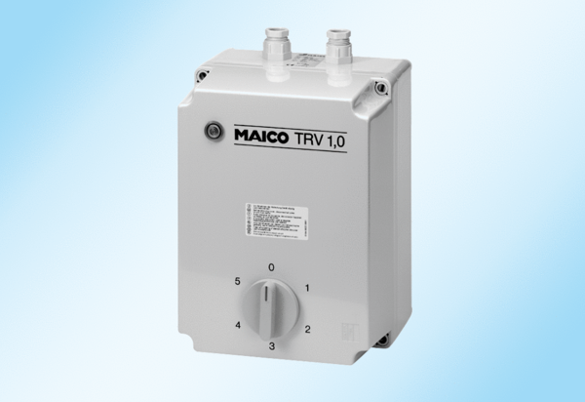5-step transformer TRV 1,7Packing unit: 1 pieceRange: C
Article number: 0157.0716Manufacturer: MAICO

