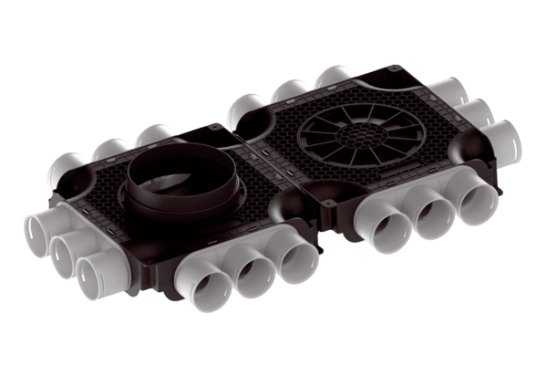Flat and compact double air distributor, made of plastic, 18-way MA-FDV18-63Packing unit: 1 pieceRange: K
Article number: 0059.2127Manufacturer: MAICO

