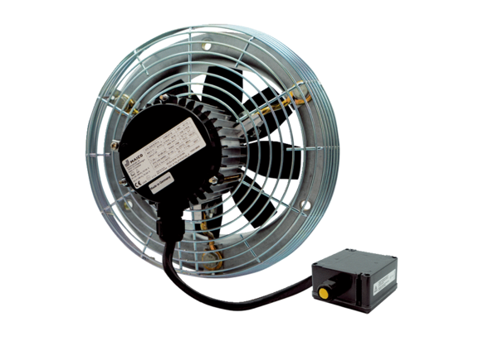Axial wall fan DZS 40/4 B Ex tPacking unit: 1 pieceRange: C
Article number: 0094.0212Manufacturer: MAICO

