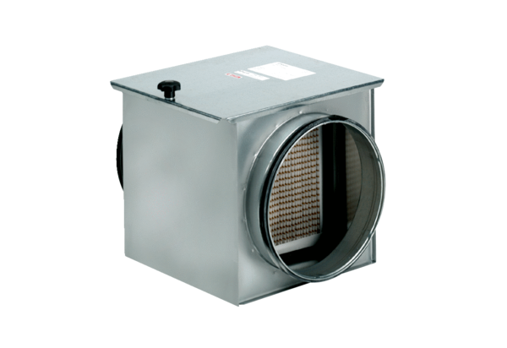Air filter TFE 35-5Packing unit: 1 pieceRange: C
Article number: 0149.0065Manufacturer: MAICO

