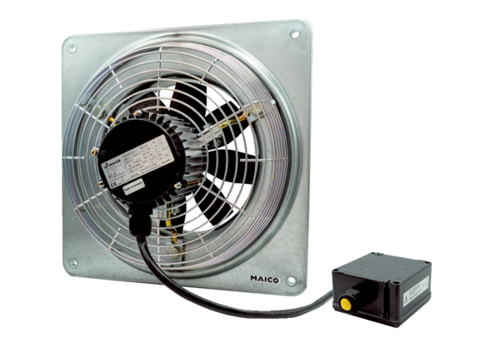Axial wall fan DZQ 45/6 B Ex tPacking unit: 1 pieceRange: C
Article number: 0083.0212Manufacturer: MAICO

