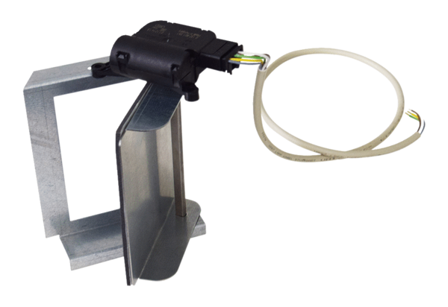Bypass for heat exchanger WS-BP 160Packing unit: 1 pieceRange: K
Article number: 0092.0569Manufacturer: MAICO

