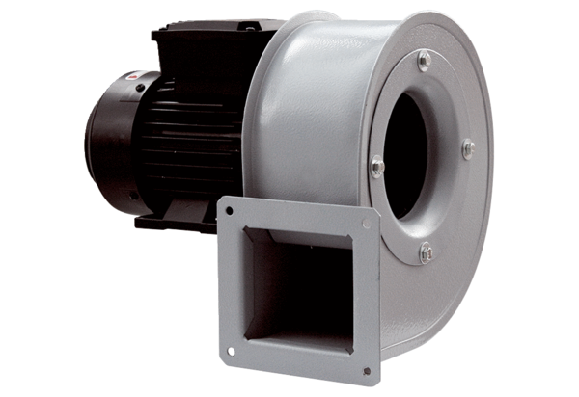Centrifugal blower GRM HT 12/2Packing unit: 1 pieceRange: C
Article number: 0073.0280Manufacturer: MAICO

