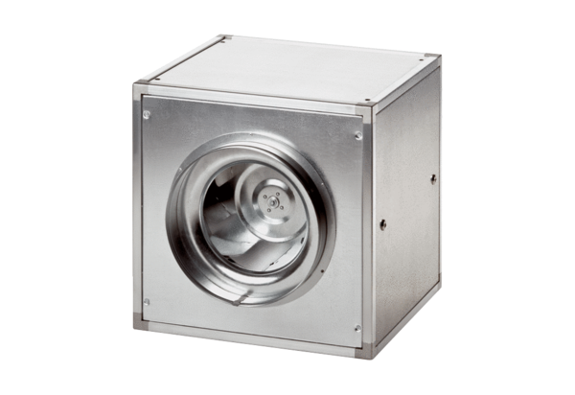Quickbox ESQ 35/4Packing unit: 1 pieceRange: C
Article number: 0080.0029Manufacturer: MAICO

