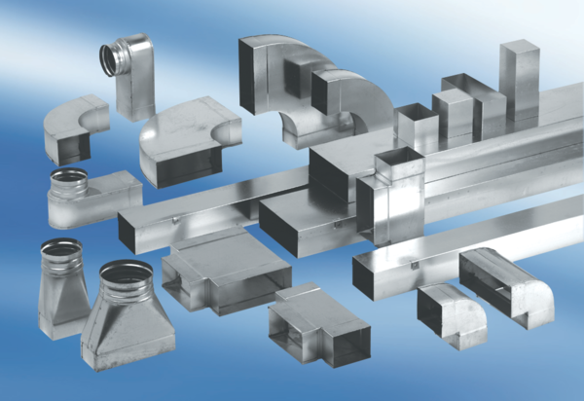90° angle elbow, right-sided asymmetrical WB90ARN80/150/80Packing unit: 1 pieceRange: K
Article number: 0055.0650Manufacturer: MAICO

