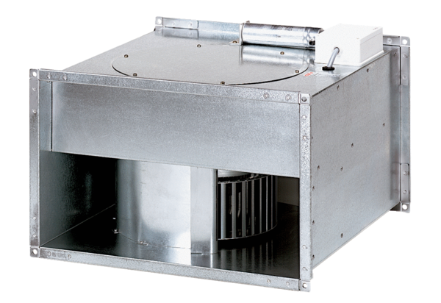Channel fan EPK 22/6 BPacking unit: 1 pieceRange: D
Article number: 0086.0650Manufacturer: MAICO

