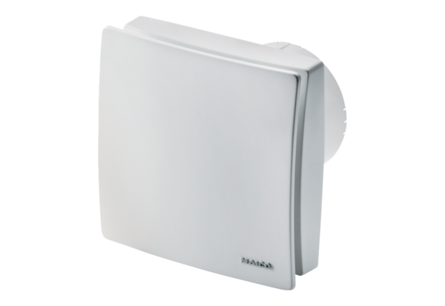Small room fan ECA 100 ipro KFPacking unit: 1 pieceRange: A
Article number: 0084.0207Manufacturer: MAICO

