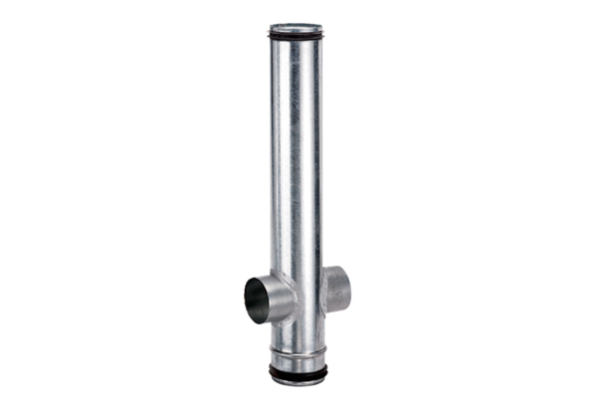Fire protection compensation element BA 100/80-2Packing unit: 1 pieceRange: B
Article number: 0093.1004Manufacturer: MAICO

