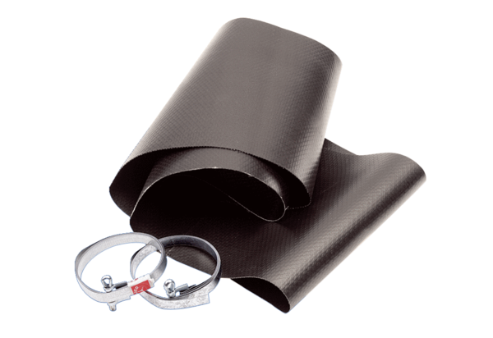Flexible cuff EL 20Packing unit: 1 pieceRange: C
Article number: 0092.0154Manufacturer: MAICO

