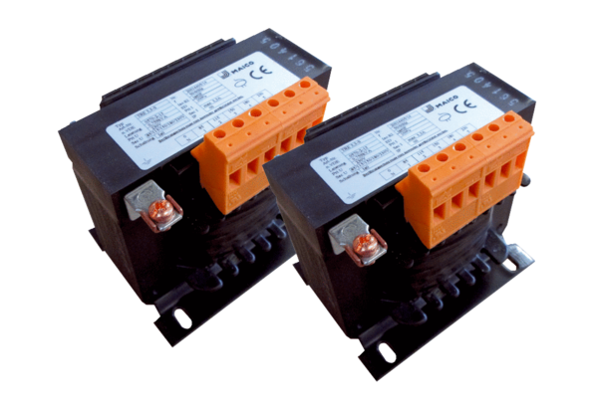5-step transformer, control cabinet TR 0,8 S-2Packing unit: 2 piecesRange: C
Article number: 0157.0151Manufacturer: MAICO

