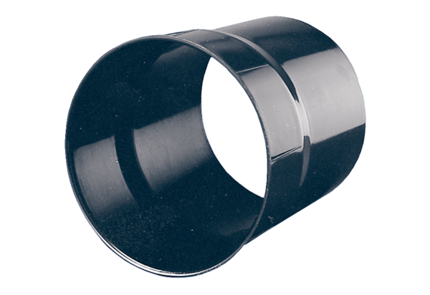Wall sleeve WH 31Packing unit: 1 pieceRange: C
Article number: 0059.0231Manufacturer: MAICO

