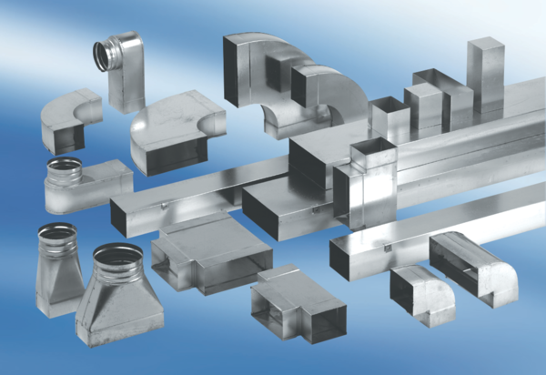Intermediate piece, symmetric USSN80/150/125Packing unit: 1 pieceRange: K
Article number: 0055.0686Manufacturer: MAICO

