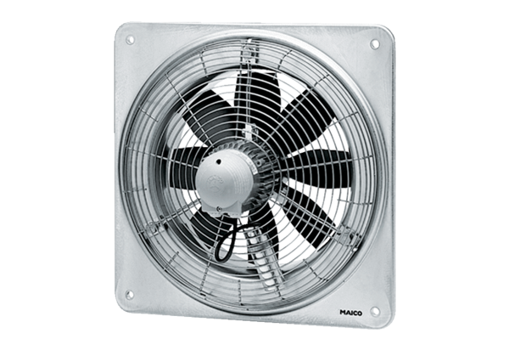Axial wall fan DZQ 56/4 BPacking unit: 1 pieceRange: C
Article number: 0083.0136Manufacturer: MAICO

