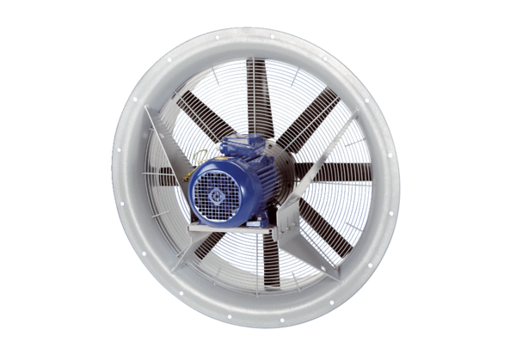Axial fan DAS 90/4Packing unit: 1 pieceRange: C
Article number: 0083.0859Manufacturer: MAICO

