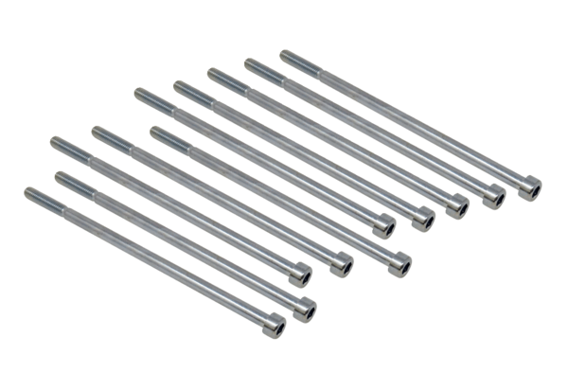Screw set for housing cover GD SR WS 75Packing unit: 10 piecesRange: K
Article number: E158.0565.0000Manufacturer: MAICO

