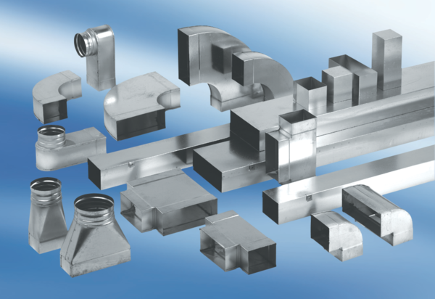Intermediate piece, symmetric USSN80/100/100Packing unit: 1 pieceRange: K
Article number: 0055.0683Manufacturer: MAICO

