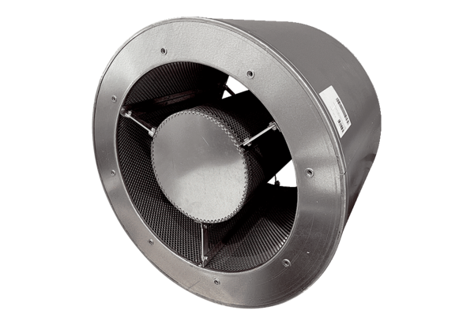Tubular sound absorber RSKI 100/2000Packing unit: 1 pieceRange: C
Article number: 0073.0252Manufacturer: MAICO

