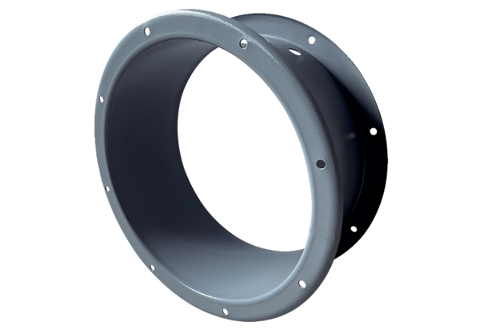Housing extension GVI 90Packing unit: 1 pieceRange: C
Article number: 0073.0203Manufacturer: MAICO

