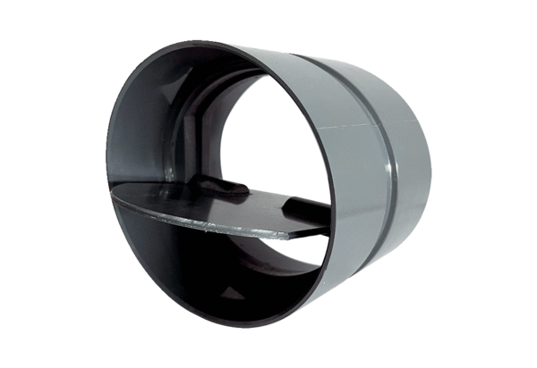Shutter VKKI 40Packing unit: 1 pieceRange: C
Article number: 0073.0477Manufacturer: MAICO

