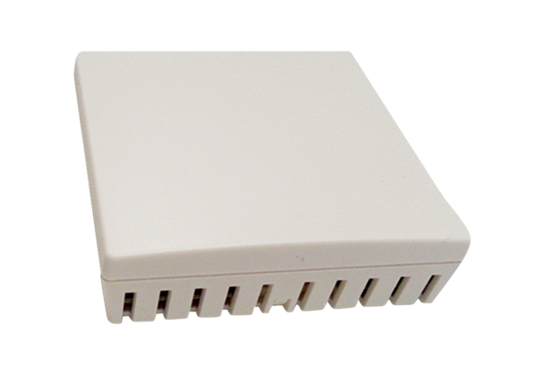Air quality controller Trio VOC EPacking unit: 1 pieceRange: K
Article number: 0157.1510Manufacturer: MAICO

