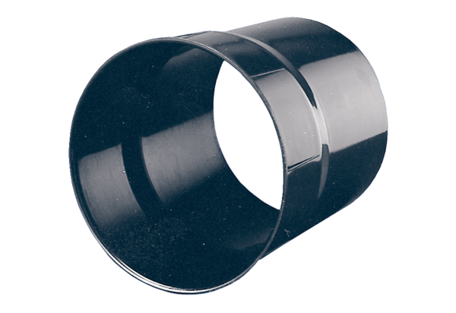Wall sleeve WH 20Packing unit: 1 pieceRange: C
Article number: 0059.0229Manufacturer: MAICO

