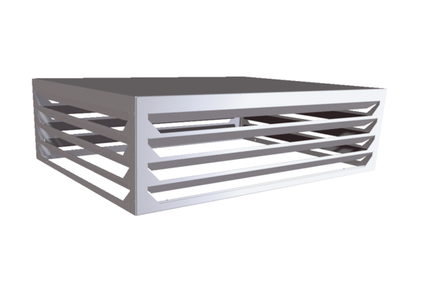Air outlet element AH CB 1200Packing unit: 1 pieceRange: L
Article number: E018.1421.0000Manufacturer: MAICO

