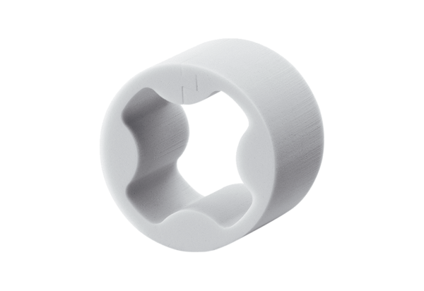Sound-absorbing element PP 45 SEPacking unit: 1 pieceRange: K
Article number: 0093.0308Manufacturer: MAICO

