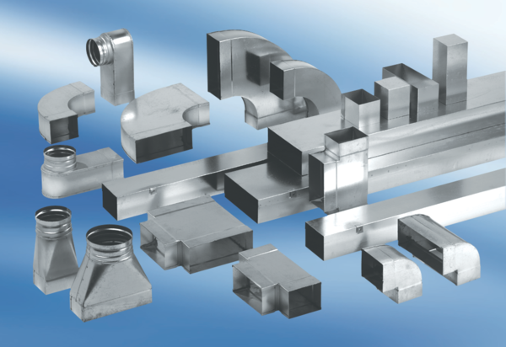90° branch, horizontal AZ90H80/150/80/150Packing unit: 1 pieceRange: K
Article number: 0055.0728Manufacturer: MAICO

