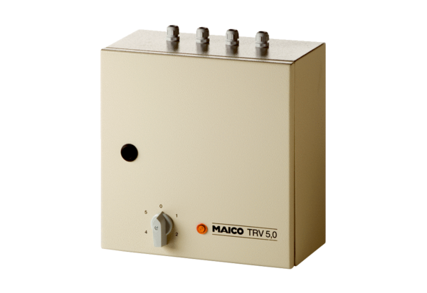5-step transformer TRV 5,0Packing unit: 1 pieceRange: C
Article number: 0157.0718Manufacturer: MAICO

