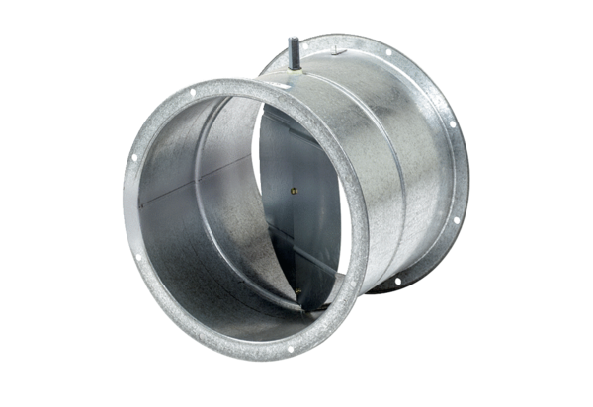Shutter, servomotor VE 30Packing unit: 1 pieceRange: C
Article number: 0093.0286Manufacturer: MAICO

