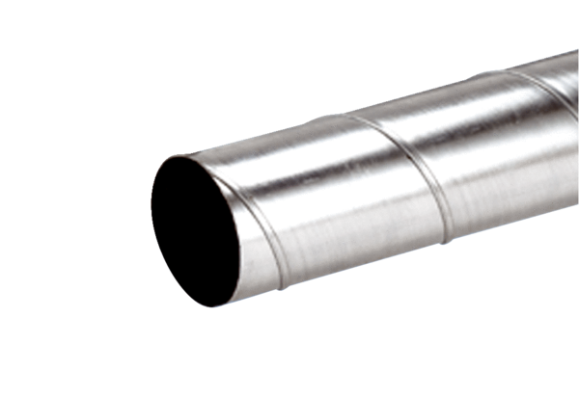Folded spiral-seams duct WFR 80Packing unit: 1 pieceRange: K
Article number: 0055.0075Manufacturer: MAICO

