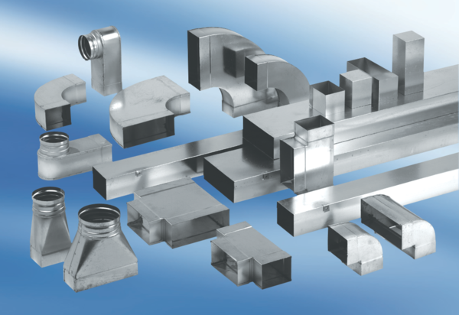45° branch, horizontal AZ45H80/150/80/200Packing unit: 1 pieceRange: K
Article number: 0055.0741Manufacturer: MAICO

