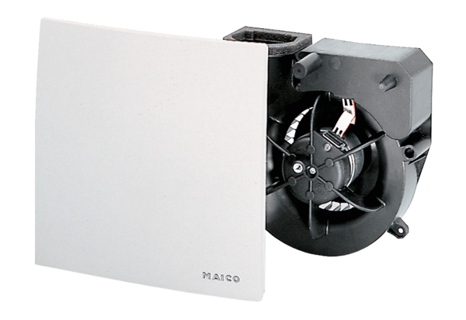Fan insert ER 60 FPacking unit: 1 pieceRange: B
Article number: 0084.0102Manufacturer: MAICO

