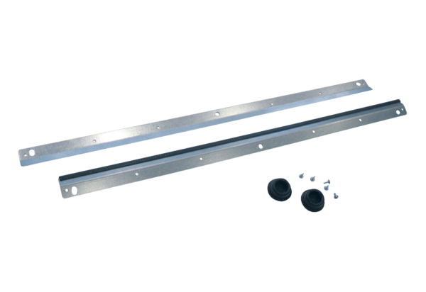Wall bracket WRK 300-400Packing unit: 1 pieceRange: K
Article number: 0018.0493Manufacturer: MAICO

