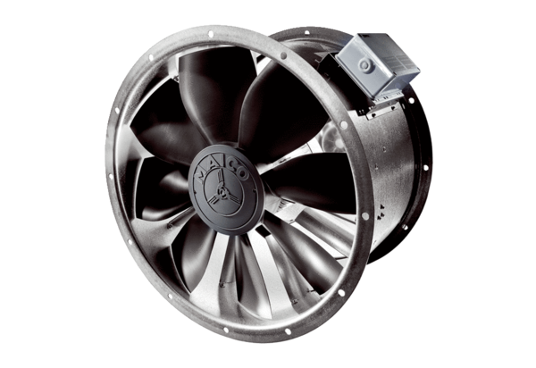DZL 45/6 BPacking unit: 1 pieceRange: C
Article number: 0086.0085Manufacturer: MAICO

