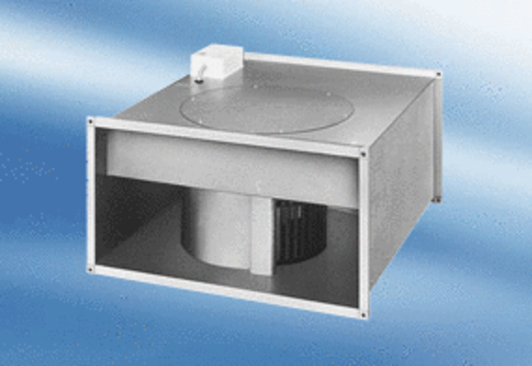Channel fan EPK 22/4 APacking unit: 1 pieceRange:
Article number: 0086.0611Manufacturer: MAICO

