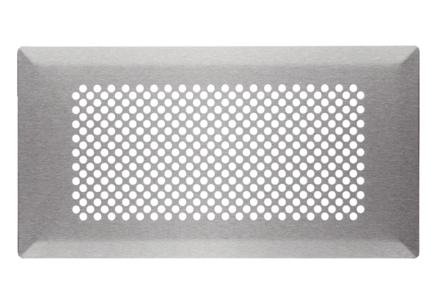Floor grille FFS-FGBPacking unit: 1 pieceRange: K
Article number: 0055.0890Manufacturer: MAICO

