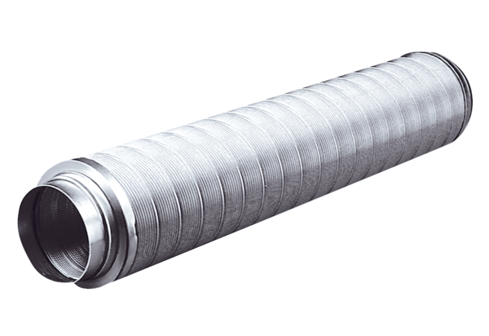Tubular sound absorber RSR 25Packing unit: 1 pieceRange: C
Article number: 0092.0317Manufacturer: MAICO

