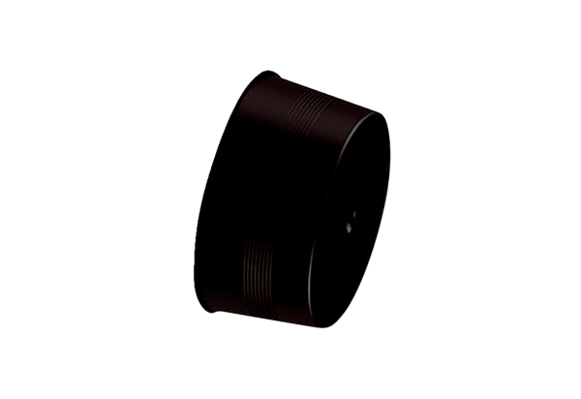Sealing cover MA-VD63Packing unit: 10 piecesRange: K
Article number: 0059.2137Manufacturer: MAICO

