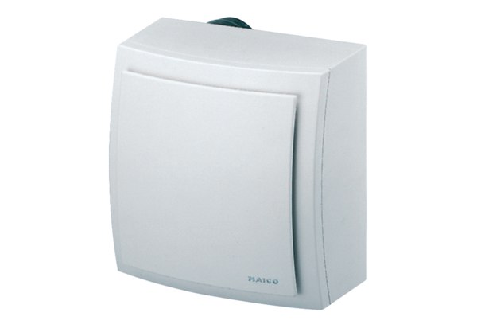Surface-mounted fan, fire protection ER-APB 100 GPacking unit: 1 pieceRange: B
Article number: 0084.0179Manufacturer: MAICO

