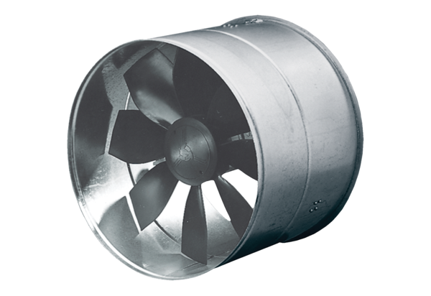AIROTHERM fan DZF 35/84 BHPacking unit: 1 pieceRange: C
Article number: 0085.0032Manufacturer: MAICO

