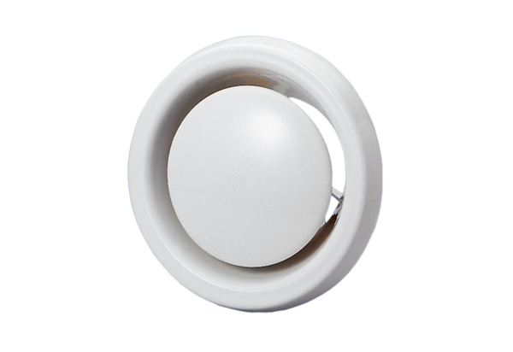Disk valve, fire protection WBV 12Packing unit: 1 pieceRange: B
Article number: 0151.0276Manufacturer: MAICO

