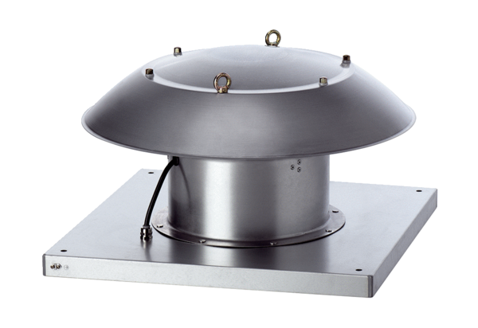Axial roof fan DZD 25/4 B Ex tPacking unit: 1 pieceRange: C
Article number: 0087.0810Manufacturer: MAICO

