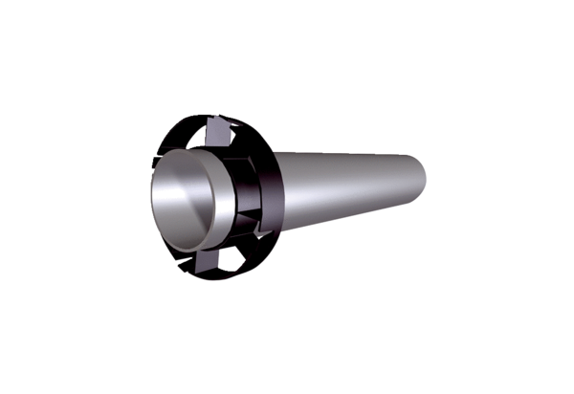Extension kit PPB 30 VSPacking unit: 1 pieceRange: K
Article number: 0093.1522Manufacturer: MAICO

