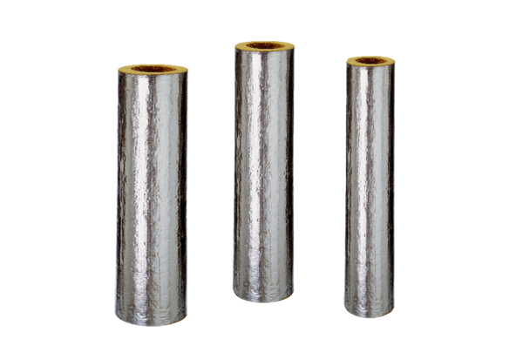Fire protection insulation BI 100Range: B
Article number: 0092.0395Manufacturer: MAICO

