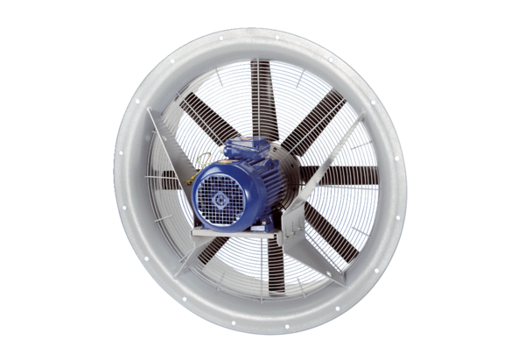Axial fan DAS 90/6Packing unit: 1 pieceRange: C
Article number: 0083.0858Manufacturer: MAICO

