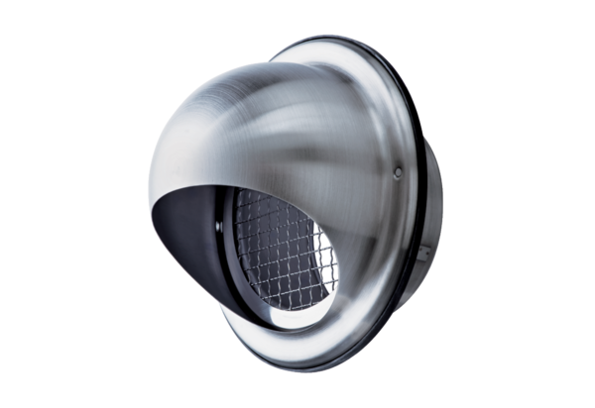Stainless steel cowl LH-V2A 16Packing unit: 1 pieceRange: C
Article number: 0151.0380Manufacturer: MAICO

