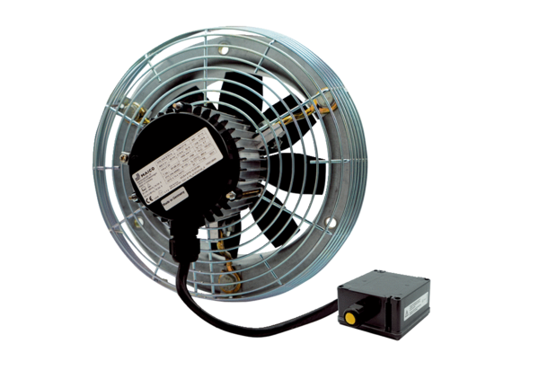Axial wall fan DZS 50/6 B Ex tPacking unit: 1 pieceRange: C
Article number: 0094.0213Manufacturer: MAICO

