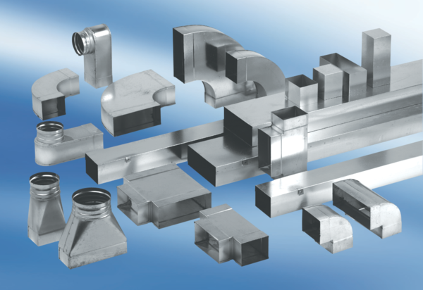Reducer, symmetrical REDS80/200/80Packing unit: 1 pieceRange: K
Article number: 0055.0702Manufacturer: MAICO

