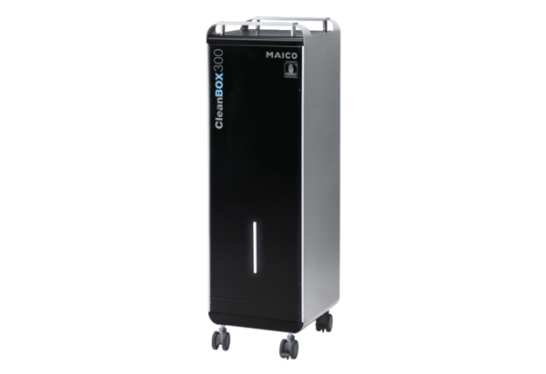Air purifier CleanBox 300Packing unit: 1 pieceRange: L
Article number: 0095.0649Manufacturer: MAICO

